“ST26943”, 2nd International Conference on Agricultural and Food Engineering, CAFEi2014”
Laboratory Calibration and Evaluation of Microwave Type Grain Flow Sensor for Yield Monitoring in Rice Combine Harvester
Renny Eka Putri^{a,}, Azmi Yahyaª, Nor Maria Adam^{b}, Samsuzana Abd Azizª
ªDepartment of Biological and Agricultural Engineering, Faculty Engineering, Universiti Putra Malaysia, 43400 UPM Serdang, Selangor, Malaysia
^{b}Department of Mechanical Engineering, Faculty Engineering, Universiti Putra Malaysia, 43400 UPM Serdang, Selangor, Malaysia

Abstract
A complete calibration test stand was constructed and instrumented to examine the effect of varying pitch and roll positions on the measurement errors of a SWR SolidFlow microwave flow sensor. Results indicated that measurement errors ranging from 2.50% to 6.82% and 1.80% to 8.86% were obtained by the changing of chute pitch (descending and ascending) and roll angle positions from 1.5° to 4.5°, respectively. Greater measurement errors were found at the low screw auger conveyor speed range. However, the magnitude of errors is within the acceptable margin for any typical wet paddy land topography.

© 2014 The Authors. Published by Elsevier B.V.
Peer-review under responsibility of the Scientific Committee of CAFEi2014.
Keywords: Crop yield mapping; microwave flow sensor; flow sensor calibration; flow measurement accuracy
- Introduction
Currently, yield mapping is one of extremely popular tool used in precision farming technology. Aimrun (2011) demonstrated that 75% of the fertilizer cost can be saved and its Return on Investment (ROI) can be increased by 26-28% if precision farming is used in Malaysian paddy fields. The major drawback of yield mapping is the accuracy of yield map, which is important for the successful implementation of precision farming. Inaccurate yield monitor readings cause errors in the yield maps, which lead to incorrect management decisions.

The accuracy of yield maps is affected by errors in the yield monitor data used to generate the maps, such as GPS coordinates, mass flow rate, cutting width, moisture content, and wrong input by the operator (Grisso et al., 2002). Earlier research conducted by Ju (2011) developed a simple, portable and rugged instrumentation system that could be directly used on any rice combine harvester from different makes and models to monitor measure and record in real time the harvested crop yield. Impact type grain flow sensor for crop yield monitoring is known to have problem of some thrown grain by the elevator conveyor in a combine not hitting the sensing impact plate. New technology of microwave solid flow sensor was used to solve the problem of impact-type sensor. A mild steel chute mounted with SWR SolidFlow microwave type flow sensor were located at the end of the clean grain auger in the combine harvester to measure the flow rate of the grain transferred by the auger into the grain tank. Despite of being able to demonstrate successfully how to monitor crop yield with interchangeable combines in the field, the SWR solid flow sensor was not subjected to proper measurement calibration and rigorous measurement accuracy evaluation. Quantifying and correcting for such errors would increase the yield map accuracy, thus improving management decisions based on yield map interpretation (Loghavi, 2008).
Furthermore, several studies have attempted to assess the accuracy of yield monitoring. Yield monitor errors as high as 18.2% with the combine harvester operating on uphill and 60.7% with the combine harvester on downhill within terrain slopes ranging 6 to 9% was reported by Kettle and Peterson (1998). Arslan and Colvin (2002) mentioned a yield monitor errors of 3.4% when the combine harvester was operating at constant ground speed and errors of 5.2% when the combine harvester was operating at varying ground speeds. Loghavi et al. (2008) conducted a laboratory study to stimulate the effect of terrain slopes on the mass flow rate measurements from an impact type sensor by varying the tilting angle of the grain elevator of a test rig. They reported an increase of 3.5 to 19.4% on the mass flow rate measurements of the grains when the grain elevator was tilted from vertical position to 10° forward or representing 17.6% slope downhill. The mass flow measurement errors increased from 6.0% at flow rates of 4.92 kg/s to 29.0% at 2.85 kg/s and 30.7% at 1.30 kg/s. While all of the research focused on Impact type grain flow sensor for determine crop yield.
The objectives of this research were to evaluate the accuracy of microwave type grain flow sensor and to examine the influence of varying field slope (both pitch and roll) for yield monitoring in rice combine harvester. The calibration test stand is capable of testing and evaluating the accuracy of various grain mass flows at same tilt position. Furthermore, this research will quantify the measurement errors of SWR Solid Flow microwave type sensor with changing pitch and roll angle positions of the sensors under simulated field conditions.

Nomenclature
GF Grain flow
V Output voltage from sensors
RPM Revolution per Minute
GPS Global Positioning Systems

2. Materials and methods

2.1. Design and development of a complete calibration stand
The mechanical components of the test stand shown in Fig. 1 include the frame, an auger-type conveyor system, and an elbow shaped chute unit housing where SWR SolidFlow microwave type flow sensor and ONO SOKKI MP-810 electromagnetic rotation detector are mounted. An auger attached to the bottom of the bin conveyed grain from the supply bin to the elbow shaped chute unit. A polycarbonate plate was made on the top of auger housing for the purpose of visibility to check whether the conveyor was grain was fully filled with grain. The auger was driven by a 7.5 hp variable speed AC Electrim Slinik electric motor through double speed chain drive system with the speed ratio of 1:1 and 1:2 interchangeable sprockets. A Panasonic VF-8Z frequency inverter was used to vary the motor speed. Another GMD Worm Gear speed reducer with ratio of 1:10 was used to reduce the motor speed to the desire auger speed. Therefore, the speed of the electronic motor was varied by the use of frequency, speed reducer, and interchangeable double speed chain drive before driving the auger. The flow measurement rate through the outlet can be varied from 0 to 5.75 kg/s. Grain was initially fed into the supply bin. The operation of the system is such that grain is transferred from the supply bin to the auger conveyor, then to the elbow shaped chute unit housing which is equipped with sensors and to the collection box. The microwave solid flow sensor was installed on the specially made chute unit of elbow shaped that was mounted at the end of the auger for measurements of grain flow in a free fall condition.
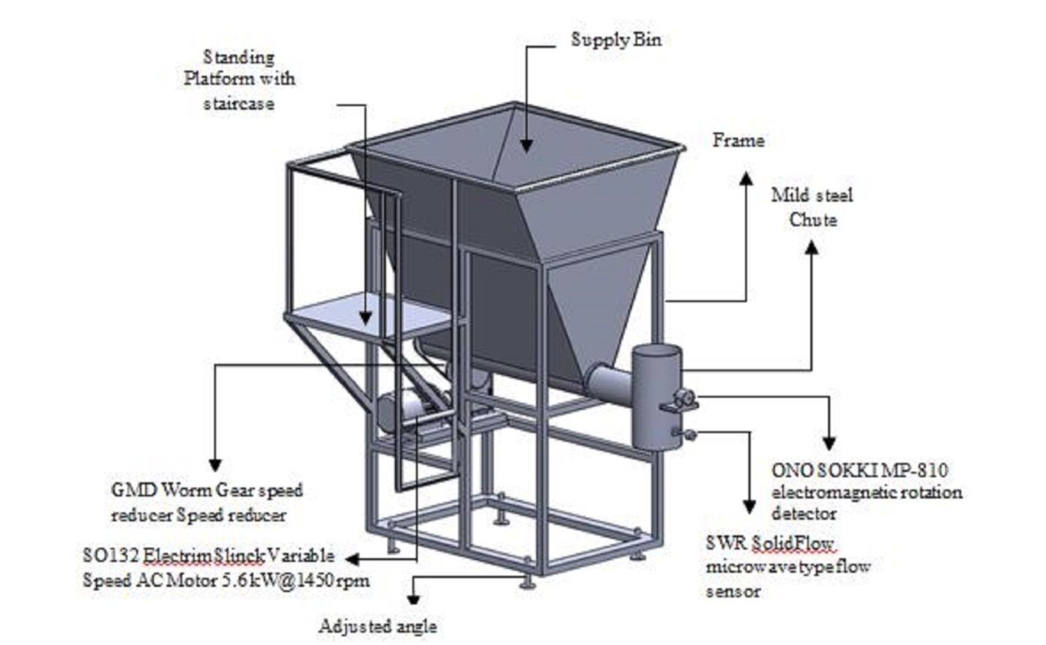

Fig. 1. The calibration test stand.

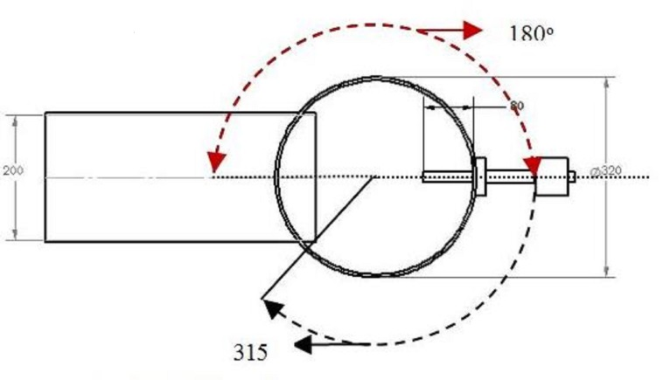
Fig. 2. Top view of SWR SolidFlow microwave type flow sensor position.

2.1.1. Data collection technique
The component for data collection and instrumentation system are Panasonic CF-19 toughbook, National Instrument CompactRio 9004 embedded system, D-link DIR-655 router, two SWR SolidFlow microwave type flow sensor, and ONO SOKKI MP-810 electromagnetic rotation detector. The detail functions of each component in the developed instrumentation system are summarized in Table 1. Flow rate of grain and elevator speed are factors of interest considered for calibrating the yield monitor in this research. The Panasonic CF-19 toughbook with in-house National Instrument LabVIEW 8.6 software was used to control and display the measured data from sensors. Wireless communication was set up between the embedded system and the toughbook by the use of D-link DIR-655 router and D-link DWA-140 USB adapter. The D-link DIR-655 router with 3 D-link ANT24-0700 antennas were fixed on the special housing box using special magnetic supports. The three D-link ANT24-0700 antennas were selected due to the ability of each antenna’s signal up to 7 dbi strength. The National Instrument CompactRio 9004 embedded system was used in processing the measured signal from sensors. It is portable rugged industrial computer embedded system designed for various field applications. The measured data from the embedded system was wirelessly transferred through the router and received by the adaptor on the toughbook. All the received measured data was stored inside the hard disk of the toughbook and subsequently display on-line on the monitor screen. These measured data were then retrieved for the purpose of analysis using Microsoft Office Excel.

Table 1. Functions of components in the instrumentation system.
Name of Component | Function
Panasonic CF-19 toughbook with in-house National Instrument LabView 8.6 software | Controls the receiving, recording and saving the measured data. Displays the measured data.
National Instrument CompactRio 9004 embedded system with NI 9221 I/O module | Controls the acquiring, conditioning, and processing the measured signal from sensors.
D-link DIR-655 router with 3 D-link ANT24-0700 antennas and a D-link DWA-140 USB adapter | Provides wireless communication between the embedded system and toughbook.
SWR SolidFlow microwave type flowsensor and evaluation unit | Measures the flow of clean grain dropping from the levelling auger.
ONO SOKKI MP-810 electromagnetic rotation detector | Measures the rotational speed of the levelling auger.
Power distribution box | Provides the input power with AC to DC converter.
Panasonic VF-8Z Frequency Inverter | Vary the auger speed via the electric motor

2.1.2. SWR SolidFlow microwave type flow sensor calibration
The SWR SolidFlow microwave type sensor with measurement range of 3 to 20,000 kg/h at ± 2 to 5% accuracy working at a maximum transmitting power of 5 mW was used to measure the grain flow in a free fall condition during calibration test. It was positioned on the special made chute unit of elbow shaped that was mounted at the end of the grain supply auger. During the calibration test, the SWR SolidFlow microwave type sensor was connected to input channel AI2 of the NI 9221 I/O module on the embedded system through evaluation unit for displaying and saving the measurement data in the hard disk of the toughbook. The SolidFlow microwave type sensor evaluation unit was operated at an input voltage of 24V for transforming the received microwave power signal to give output signal having a range of 4 to 20mA. Then, the output current signal was converted to voltage with a range of 1 to 10V by using a 500 Ω resistance.
Regression command in Microsoft Excel Spreadsheet was employed to analyze the measured data obtained from laboratory calibration. The respective formulated calibration equations are crucial and were used in the LabVIEW program to determine the actual measurements of various yield parameters by the sensors. A series of calibration tests were conducted to establish a calibration curve relating the grain flow rate to speed auger. The auger was driven by a 7.5 hp variable speed AC electric motor through double speed chain drive system with the speed ratio of 1:1 and 1:2 interchangeable sprockets. A frequency inverter was used to vary the motor speed. Another gearbox with ratio of 1:10 was used to reduce the motor speed to the desire auger speed. A Panasonic VF-8Z frequency inverter was used to vary the auger speed to operate between 45 to 149 rpm by changing the setting of the frequency inverter at increments of 5 Hz from 30 to 50 Hz range. These tests were replicated three times at each speed auger and the data was used to construct a calibration curve.
Many empty collection boxes were prepared. For each test, an empty collection box was placed directly below the elbow shaped chute unit to collect the falling grains at a measured time period. The weight of the collected grain in the box at different corresponding flow rates was weighed by using a Sarturius GMBH Gottingen digital electronic balance. The total collected grains were weighed and recorded. Time of collection was measured with a stop watch. The actual flow rates of grain are calculated from weight of grains accumulated after deducted weight of box divided collection time. A minimum stabilization period of 10 seconds after switching on the motor to attain steady-state flow was practiced before data logging was initiated for another 5 seconds. The overall procedures were repeated three times and finally the graph of actual flow rates against measured voltages from sensor, and the graph of actual grain flow rates against auger speeds were plotted. The calibration test considered the best position of sensor for getting accurate reading of grain flow rate. Position of sensor will affect microwave flow sensor reading. The combination of two different sensor orientations (i.e. 180º and 315º) and three different extrusions (i.e. 3 cm to 9 cm) were used in this test (Fig. 2). The test was repeated three times per each treatment. The graph of actual real time voltage from sensor against flow rate was plotted. The best selected position was selected based on R² value of regression equation.

2.1.3. Statistical analysis of experimental data
A series of repeatable test were conducted under steady state grain flow measurement and simulated changes in ground slope. In each test, the flow cycle was repeated three times. Throughout this paper, measurement for the reference scale system was considered in real time flow rate measurement. The term "error" refers to the percentage of difference of the real-time flow measurements by the sensor against the average flow measurements by weighing method. A statistical analysis was performed on the experimental data obtained using Statistical Analysis System (SAS) software. Analysis of Variance (ANOVA) was conducted to determine the significance of the chute position, level and auger speed on the measured flow rate. The treatments considered were that of sensor position has it affect the flow rate. Also, Dun-can’s Multiple Range Test was conducted to compare the means of the treatments. In order to compare the flow rate of the paddy subjected to the respective treatments, the SAS software was used to perform regression analysis on flow rate data obtained from the experiment.

2.2. SWR SolidFlow microwave type flow sensor responses under different simulated terrain conditions
The test was conducted to examine the influence of varying field slope (both pitch and roll) on accuracy level of microwave solid flow sensor. To simulate the ground slope, the test stand was tilted at pitch and roll positions. The experiment were carried out in two separate test (i.e. pitch and roll) on various slope position of the stationary test stand to simulate the tilted position of combine harvester. Four chute orientation configuration (i.e. pitch ascending, pitch descending, roll right and roll left), three chute orientation level (1.5º, 3.0 º, and 4.5 º), and ten different flow rate from 44 rpm to 149 rpm were investigated with the instrumented calibration stand set-up. Slope angles of 1.5º, 3º, and 4,5º degree were chosen for each stage of trials. Yap (2006) mentioned that the pitch and roll of paddy field in Tanjung Karang, Selangor Malaysia is around 0.1º – 1.5º and 0.1º – 2º, respectively. The aim of the test was to determine the percent error as a function of real time flow rate measurement affected by the slope during field operations. The auger speed was varied to operate from 45 to 149 rpm by changing the setting of frequency inverter. This test was carried out to know whether tiled pitch and roll, each at three slopes of 1.5º, 3º, and 4.5º have effect on the grain flow. These tests were performed for 3 times replication for each Analysis of variance (ANOVA) performed to determine statistical difference on effect of slope to the grain flow.

2.3. Accuracy test
The aim of the test was to ensure that the real time sensor reading was the same with the actual readings. To determine the accuracy of the flow rate measurement sensor, the output of the two reading should compared. One of the method, the real time reading of sensor and the actual flow rate measurement from average weighing were plotted in the one graph. The actual flow rate is the total paddy weigh divided by time. Test will be conducted for all conditions (i.e. pitch and roll). These tests were also run in ten different auger speeds.

3. Results and discussion

3.1. Sensor calibration
Microwave solid flow sensors in the instrumentation system have been successfully calibrated to determine the relationship between the values of quantities from the measuring sensors with the corresponding values realized by standards measured parameters with high confidence under flat conditions. Distance of sensor extrusion was decided based on distance of free falls paddy to the tip of the sensor. The profile of the falling rice was closed to the sensor tip with sensor orientation at 315º than with sensor orientation of 180º. Thus, sensor extrusions of 7 cm, 8 cm, and 9 cm were used for sensor orientation of 180º and sensor extrusions of 3 cm, 5 cm and 7 cm were for sensor orientation of 315º.The results showed that the best sensor position is on totally flat ground at 180º orientation and 8 cm extrusion of the chute cross section with R² value 0.9400 (Putri, 2014). The following calibration equations were obtained for the microwave solid flow sensor:

GF = 0.914V + 0.929 with R² = 0.9400 (1)
where,
GF = Grain flow (kg/s)
V = Output voltage from sensors (V)

The linear regression equation was used in the Lab VIEW program to obtain the actual real time readout for the sensor.

3.2. Steady state flow under simulated field condition
The response of grain flow sensor reading was also determined under the simulated ground slope. Pitch positions at level -4.5º, -3.0º and -1.5º was treated as pitch descending while pitch positions at level +4.5º, +3.0º and +1.5º pitch was treated as pitch ascending. In addition, roll positions at level -4.5º, -3.0º, -1.5º was treated roll left, while roll positions at level +4.5º, +3.0º, and +1.5º was treated as roll right. During data collection, the first five seconds data of the experiment was not used; due to the stabilization period of data. Data were taken after five seconds or when the readout of voltage was constant. The mean square of grain flow as affected by four cute position (i.e. pitch ascending, pitch descending, roll right and roll left), three different level (i.e. 1.5º, 3.0º, 4.5º) and ten different auger speed (i.e. 44, 52, 59, 67, 75, 89, 104, 119, 134, and 149) are compared in Table 2. At all the chute positions, levels and the auger speed were found to be significant at 10% significant level. Kormann et al. (1998) also found significant effect of tilting the elevator system on mass flow sensor accuracy. Duncan's multiple range tests were used to perform a comparison of the means of flow rate (Table 3, 4 and 5).

Table 2. Analysis of variance for the chute position, level and auger speed of the sensor with respect to voltage reading of SWR SolidFlow microwave type sensor.

Source of Variation | DF | Sum of  Square | Mean Square | F Value | P Value ^{a)}
Chute orientation configuration | 3 | 30.1293051 | 10.0431017 | 773.56 | <.0001***
Chute orientation level | 2 | 1.6002664 | 0.8001332 | 61.63 | <.0001***
Chute orientation configuration * Chute orientation level | 6 | 12.2281705 | 2.0380284 | 156.98 | <.0001***
Auger speed | 9 | 447.5488815 | 49.7276535 | 3830.23 | <.0001***
Chute orientation configuration * Auger Speed | 27 | 19.0762292 | 0.7065270 | 54.42 | <.0001***
Chute orientation level *Auger Speed | 18 | 7.8565985 | 0.4364777 | 33.62 | <.0001***
Chute orientation configuration * Auger Speed* Chute orientation level *Auger Speed | 54 | 10.5828467 | 0.1959786 | 15.10 | <.0001***
*Significant at 10% significant level or 0.1 probability level. **Significant at 5% significant level or 0.05 probability level. ***Highly significant at 1% significant level or 0.01 probability level.

Table 3. Duncan’s multiple range tests on the mean voltage reading of SWR SolidFlow microwave type sensor for difference chute position.

Chute orientation configuration |  | Mean Voltage SWR  Flow Sensor ^{a)} |  | Duncan grouping ^{b)}
Pitch Descending | 2.84199 |  | A
Roll Left | 2.48846 |  | B
Roll Right | 2.43361 |  | C
Pitch Ascending | 2.02646 |  | D
^{a)} Mean computed from 360 samples.
^{b)} Duncan grouping showing different letters indicates that the mean voltage reading of SWR flow sensor at four treatments is significantly different at 5% significant level or 0.05 probability level.
Table 4. Duncan’s multiple range tests on the mean voltage reading of SWR flow sensor for difference level.

Chute orientation level | Mean Voltage of SWR Flow Sensor ^{a)} | Duncan grouping ^{b)}
1.5º | 2.53852 | A
3º | 2.42389 | B
4.5º | 2.38047 | C
^{a)} Mean computed from 360 samples.
^{b)} Duncan grouping showing different letters indicates that the mean voltage reading of SWR flow
sensor at three treatments is significantly different at 5% significant level or 0.05 probability level.

Table 5. Duncan’s multiple range tests on the mean voltage reading of SWR SolidFlow microwave type sensor for difference auger speed.

Screw Auger Conveyor Speed, RPM | Mean Voltage SWR Flow Sensor ^{a)} | Duncan grouping ^{b)}
149 | 4.76674 | A
134 | 4.07046 | B
119 | 3.26262 | C
104 | 2.36936 | D
89 | 1.89837 | E
75 | 1.75897 | F
67 | 1.66973 | G
59 | 1.61098 | H
52 | 1.55830 | H I
44 | 1.51074 | I
^{a)} Mean computed from 360 samples.
^{b)} Duncan grouping showing different letters indicates that the mean voltage reading of SWR flow sensor of the nine treatments is significantly different at 5% significant level or 0.05 probability level.

Table 3 shows significant different of the voltage reading of SWR solid flow sensor within the chute orientation configuration (i.e. pitch ascending, pitch descending, roll right and roll left). However the different of mean comparison voltage between pitch ascending and pitch descending was 28.67%, meanwhile percentage different of mean comparison voltage between roll left and roll right was only 2.25%. It could be concluded the mean voltage reading of SWR solid flow sensor for roll right and roll left are same, so it means for accuracy test could represented by one roll angle only.
Table 4 and 5 show voltage reading of SWR solid flow sensor have significant different within levels orientation and the auger speed of SWR solid flow sensor. However the mean voltage reading of SWR flow sensor for difference auger speed had two trends. Within the low auger speed (44 RPM to 75 RPM) had lower percentage different of the mean voltage reading than the high auger speed (89 RPM to 149 RPM). Moreover the percentage different of the high auger speed seven times more than the low auger speed. In addition at low auger speed, there is no significant different between 52 RPM and 59 RPM. Fig. 3 presents the voltage response to simulated pitch descending position at 4.5º at different auger speed. The readout voltage of SWR solid flow sensor indicated that voltage reading of microwave solid flow sensor increase with the increasing of speed auger. It could be seen that SWR solid flow sensors are low sensitive at low speed auger. The voltage reading value was almost the same for low speed auger (44 RPM to 75 RPM).
The response of voltage reading of the sensor was different with the difference sensor position orientation at different speed auger (Table 6). It shows equations and R² value of relationship voltage of sensor reading against flow rate. The result indicates that the pitch angle descending position of microwave solid flow sensor was excellent (R² = 0.9050). It is the effect of total grain quantity in the elbow chute near the tip of the sensor and also gravity of paddy. Then, the lowest accuracy was at pitch angle ascending position (R² = 0.7470), because the density of paddy dropped not full. The results show voltage reading of roll angle right and roll angle left are same, which is indicated by the R² value was almost the same 0.8700 and 0.8820, respectively. It can be concluded that the effect of the angle slope between right and roll left roll was the same.
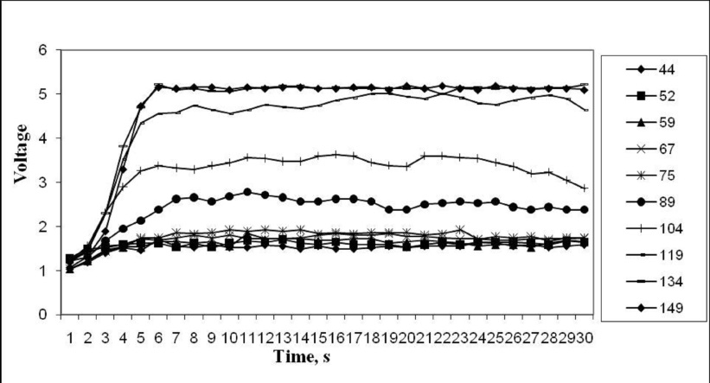
Fig. 3. Voltage response to simulated pitch descending position at 4.5º at different auger speed.
Table 6. Equation for every condition at tilled position.
No. | Chute orientation configuration | Equation | R²
1 | Pitch angle ascending | GF = 1.051V + 1.179 | 0.7470
2 | Pitch angle descending | GF = 0.941V + 0.818 | 0.9050
3 | Roll angle right | GF = 1.018V + 1.01 | 0.8700
4 | Roll angle left | GF = 0.985V + 1.037 | 0.8820

Grisso et al. (2002) mentioned the yield monitor calibration have significant impact to the yield monitor accuracy. Finally, Calibration equation of SWR solid flow sensor were made by using whole the data from the chute position (pitch ascending, descending pitch, roll right and roll left) and all levels of orientation (1.5º, 3º and 4.5º). However low auger speed data was emitted in the calibration test, due to from observation in the field indicates that the majority instantaneous flow rate was in high speed. Likewise the equation to describe the flow rate trend for the voltage reading of the sensor is as follow:

GF = 0.665V+2.364 with R² = 0.876 (2)
where,
GF = Grain flow (kg/s)
V = Output voltage from sensors (V)

3.3. Accuracy determination under controlled laboratory conditions
Accuracy tests were developed to compare the real-time flow measurements by sensor against the average flow measurements by weighing method. Four elbow chute orientation configuration were pitch ascending, pitch descending, and roll left and roll right and three orientations level were 1.5º, 3º, and 4.5º. Accuracy test was conducted in low auger speed with range 44 RPM to 75 RPM and high auger speed with range 89 RPM to 149 RPM.

3.3.1. Pitch analysis
Pitch angle was divided into two parts, namely pitch ascending and pitch descending. However positive angle indicated combine travel uphill (ascending) while negative angle reflected downhill operation (descending). Pitch descending and ascending were obtained by changing angle positions from 1.5º to 4.5º. In pitch ascending, the error was increase as increasing of the slope. The lowest error was at slope 1.5º and the highest error was at slope 4.5º with error 5.18% and 6.82%, respectively. However, low auger speed error is higher than the high auger speed. Low auger speed with a mean speed of 59.4 ± 10.67 RPM has error ranging 8.18% to 11.65%, while high auger speed with the mean speed of 119 ± 20.79 RPM has error range 2.06% to 12.74%. Conclusively, for both sides (i.e. low auger speed and high speed) found error increase with increasing level. By increasing the level, error increased due to the slope of the given effect to drop rice falls closer to the tip sensor at high auger speed and low speed. The higher error in low auger speed compared to high auger speed was due to effect of amount total grain quantity in the chute near the tip of the sensor and also the gravity of paddy. In addition, during the lowest auger speed test, density of paddy drop was not full. In order to demonstrate the effect of angle positions and error at overall speed has been plotted in graph (Fig. 4). It can be seen that the pitch ascending had higher error compared to pitch descending.

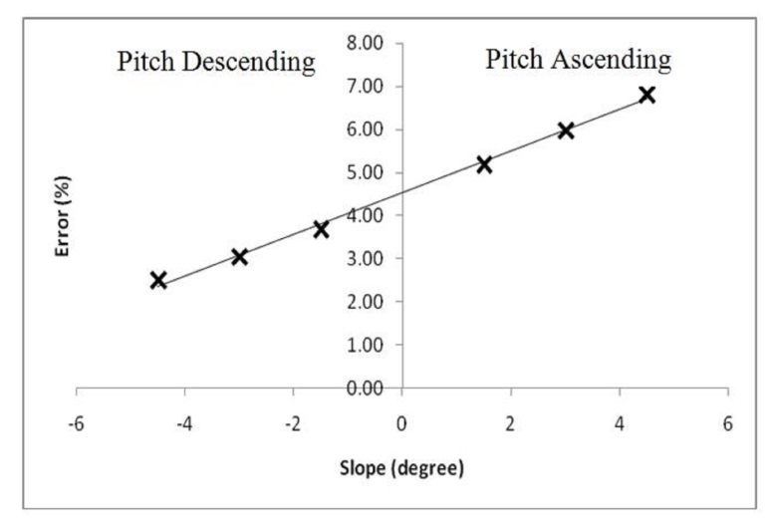

Fig. 4. Error of SWR solid flow sensor during pitch position (ascending and descending).
Unlike pitch ascending (uphill), pitch descending (downhill) error increase with increasing levels of both speeds (low auger speed and high auger speed). The lowest error was at slope 4.5º and the highest error was at slope 1.5º with error 2.50% and 3.68%, respectively. Similarly with pitch descending, pitch ascending has a higher error in low auger speed. The error range for low speed auger at pitch descending was 1.20% to 3.69%, while for high speed auger was 0.15% to 4.82%. Overall the total error range for pitch descending was 2.50% to 6.82%. Pitch descending has lower error compared to pitch ascending. It was due to the difference in distance of the dropping grains to the tip of sensors. Again, the difference in distance dropping paddy grain to the tip of the sensor will effect of the sensor reading. During the pitch ascending, the distance was a closer compared to the pitch descending. Means increasing slope for pitch descending the profile distance paddy grain dropped closer to the tip sensor, but for pitch ascending the distance farther.
Kettle and Peterson (1998) reported yield monitor errors as high as 18.2% with the combine harvester operating on uphill (pitch ascending) and 60.7% with the combine harvester on the downhill (pitch descending) within terrain slopes ranging 6 to 9%. However, Loghavi et al. (2008) conducted a laboratory study to simulate the effect of terrain slopes on the mass flow rate measurements from an impact type sensor by varying the tilting angle of the grain elevator of a test rig. They reported an increased between 3.5 to 19.4% on the mass flow rate measurements of the grains when the grain elevator was tilted from vertical position to 10° forward or representing 17.6% slope downhill. Yup (2010) claimed that the pitch angle of paddy field in Malaysia was 0.1º to 1.5º. Based on this information, if using the instrumentation system on board in combine harvester has error approximately from 2.50% to 3.68%. This point is obtained from the results of accuracy tests, which is showing pitch ascending error at level 1.5º was 5.18% while for the descending pitch at the same level of 1.5º is 3.68%. It can be concluded that the system is acceptable for monitoring the yield of paddy in paddy field Malaysia.

3.3.2. Roll analysis
Roll angle was indicated as a reference in the travel direction of combination of harvester during operations. In contrast to the pitch which indicated the combine harvester especially when walking uphill or downhill, roll angel was derived from the roll right and roll left that were merged into one. It was due to the results showed during the steady state of flow experiments under the simulated field conditions, which indicated that the reading percentage in the difference of mean voltage respond was 2.25% between left roll angle and right roll angle. Also, from the relationship voltage of sensor reading against flow rate, it was said to have the same trend and R². The results showed that the error increased as there was an increasing level orientation, therefore, the lowest error was found at the level of 1.5º with 1.80% and the highest error was at 4.5º with 8.86%. To be more specific, the error at low speed auger was lower than the error at high speed auger. The range of error was from 1.16% to 7.24% for low auger speed and 1.39% to 2.68% for high auger speed. The result show that the error increased as increasing level orientation, the lowest error ranges was from 1.80% to 8.86%. More specifically, the error at low speed auger is lower than error at high speed auger. The range of error was 1.16% to 7.24% for low auger speed and 1.39% to 2.68% for high auger speed. Furthermore, Yap (2010) mentioned that the roll level in of rice field in Malaysia was from 0.1º to 2º. Compared to the accuracy test of the instrumentation system, the error wills was held at 1.8 % especially when board embedded system was used in combine harvester for Malaysia’s rice. In addition, by combining all data and using the average value flow rate at each level of orientation, it can be concluded that errors were found at 3.48%, 1.81%, and 3.76% for pitch ascending, pitch descending and roll, respectively. The lowest error was found at pitch descending position or when the combine harvester travelled downhill. The highest error was found when the combine harvester operated uphill.
4. Conclusions
A calibration test stand was built and used to successfully evaluate the accuracy of SWR SolidFlow microwave type sensor with the flow rates of 0 to 5.75 kg/s, and also to quantify the accuracy of the sensor for real-time measurement of grain flow under a simulated laboratory rice combine test set-up. The result indicated that the accuracy of this microwave type flow sensor was excellent (R² = 0.9400) on flat condition. The simulated combine harvester going downhill or uphill has a significant effect on flow rate readings of the sensor with chute position, level and auger speed. Flow rate measurement errors ranging from 5.18% to 6.82% with pitch ascending from +1.5° to +4.5° and measurement errors ranging from 2.50% to 3.68% with pitch descending from -1.5° to -4.5°. Concurrently, measurement errors ranging from 1.8 % to 8.86% were obtained by changing the roll angle positions from 1.5° to 4.5°. Generally, these measurement errors increased with ascending slopes and increasing roll angles.
References
Aimrun, W., Amin, M.S.M., Yahya A. 2011. Comparison of Precision Farming and Conventional Practices for Fertilizer Management in Malaysian Paddy Fields. Proceedings of the 4th Asian Conference on Precision Agriculture, Obihiro, Japan.
Arslan, S., T. S. Colvin, 2002. An Evaluation of the Response of Yield Monitors and Combines to Varying Yields. Precision Agriculture 3, 107-122.
Grisso, R.D., Jasa, P.J., Schroeder, M.A., Wilcox, J.C., 2002. Yield Monitor Accuracy: Successful Farming Magazine Case Study. Applied Engineering in Agriculture 18(2), 147–151.
Ju., O.Y., 2011. Development of a portable, Real-Time, Wireless Crop Yield Monitoring System on Rice Combine. Publish by Thesis. University Putra Malaysia.
Kettle, L.Y., Peterson, C.L., 1998. An evaluation of Yield Monitors and GPS Systems on Hillside Combines Operating on the Steep Slopes in the Palouse. ASAE Paper No. 98-1046.
Kormann, G., Demmel, M., Auernhammer., 1998. Testing Stand for Yield Measurement Systems in Combine Harvesters. ASAE Paper No. 98-1053.
Loghavi, M., Ehsani, R., Reeder, R., 2008. Development of a Portable Grain Mass Flow Sensor Test Rig. Computers and Electronics in Agriculture, 61(2), 160-168.
Putri, Renny Eka, et al. 2014. Calibration and Accuracy Determination of a Microwave Type Sensor For Measuring Grain Flow. Advanced Materials Research Vols. 931-932 (2014) pp 1592-1596.
Yap, Y.K.., Yahya, A., Jamuar, S., Ruslan, R., Nordin, L., Halid, M., Ninomiya, S., 2006. Design and Development of Rice Combine Harvester Instrumentation System for Crop Yield and Field Performance Mapping. AFITA 2006: The Fifth International Conference of the Asian Federation for Information Technology in Agriculture, Bangalore, India, 301-311.

* Corresponding author. Tel.: +603-894466421; fax: +603-894466425 E-mail address:renny.ekaputri@yahoo.co.id

